From Evangelical Lutheran Hymn-Book (1918)

23
For the Jews

Almighty and Everlasting God, Who lovest to show mercy; Hear the prayers which we offer unto Thee for Thine ancient people, that, acknowledging Jesus Christ, Who is the Light of truth, they may be delivered from their darkness; through the same, Thy Son, our Lord. Amen.

24
For the Heathen

Almighty and Everlasting God, Who desirest not the death of a sinner, but wouldest have all men to repent and live; Hear our prayers for the Heathen; take away iniquity from their hearts, and turn them from their idols unto the living and true God, and to Thine only Son; and gather them into Thy holy Church, to the glory of Thy Name; through Jesus Christ our Lord. Amen.

37
For the Sick

Almighty, Everlasting God, the eternal Salvation of them that believe; Hear our prayers in behalf of Thy servants who are sick, for whom we implore the aid of Thy mercy, that being restored to health, they may render thanks to Thee in Thy Church; through Jesus Christ our Lord. Amen.
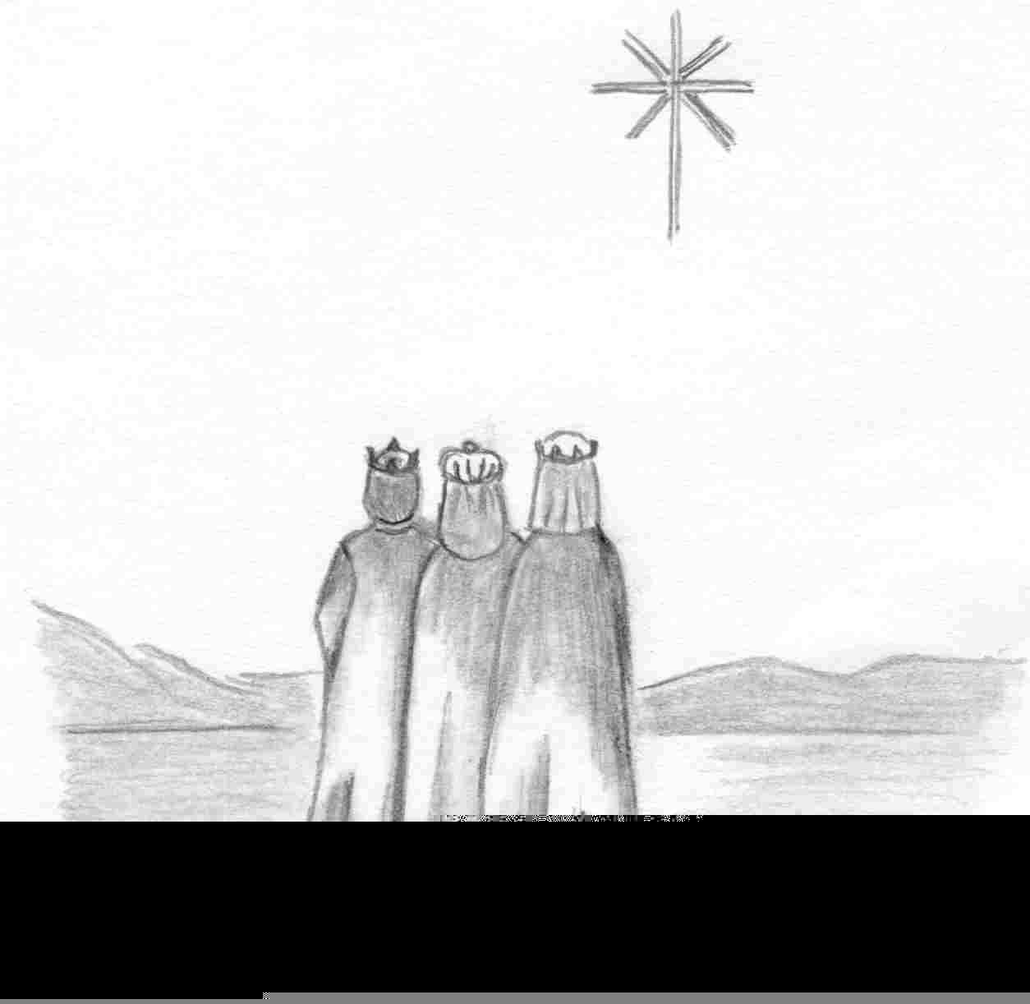
Where is He Who has been born
King of the Jews?
Change this frame and the box above by clicking the body of the text and adding the particulars.
The artwork is by Sharon Geiser. Permission to use this copyrighted graphic is limited to congregational use. The Evangelical Lutheran Hymn-Book (Concordia Publishing House, 1918) is in the public domain.

This bulletin cover provided by www.scholia.net and is made available without cost.

6 January Anno Domini 2005

Epiphany
Where is He Who has been born
King of the Jews?
To place the graphic on this page:
Copy the graphic on the previous page.
Click on the open space above and a graphic box should appear. Paste the graphic.

Change this frame and the box above by clicking the body of the text and adding the particulars. (See the previous page for an example.)
The artwork is by Sharon Geiser. Permission to use this copyrighted graphic is limited to congregational use. The Evangelical Lutheran Hymn-Book (Concordia Publishing House, 1918) is in the public domain.

This bulletin cover provided by www.scholia.net and is made available without cost.

6 January Anno Domini 2005

Epiphany

From Evangelical Lutheran Hymn-Book (1918)

23
For the Jews

Almighty and Everlasting God, Who lovest to show mercy; Hear the prayers which we offer unto Thee for Thine ancient people, that, acknowledging Jesus Christ, Who is the Light of truth, they may be delivered from their darkness; through the same, Thy Son, our Lord. Amen.

24
For the Heathen

Almighty and Everlasting God, Who desirest not the death of a sinner, but wouldest have all men to repent and live; Hear our prayers for the Heathen; take away iniquity from their hearts, and turn them from their idols unto the living and true God, and to Thine only Son; and gather them into Thy holy Church, to the glory of Thy Name; through Jesus Christ our Lord. Amen.

37
For the Sick

Almighty, Everlasting God, the eternal Salvation of them that believe; Hear our prayers in behalf of Thy servants who are sick, for whom we implore the aid of Thy mercy, that being restored to health, they may render thanks to Thee in Thy Church; through Jesus Christ our Lord. Amen.

